**Logical Operators**

 An **operator** is a symbol that operates on a value to perform specific mathematical or logical computations. They form the foundation of any programming language. In C++, we have built-in operators to provide the required functionality.

An operator operates the **operands**. For example,

int c = a + b;

Here, ‘+’ is the addition operator. ‘a’ and ‘b’ are the operands that are being ‘added’.

**Operators in C++ can be classified into 6 types:**

1. Arithmetic Operators
2. Relational Operators
3. **Logical Operators**
4. Bitwise Operators
5. Assignment Operators
6. Ternary or Conditional Operators

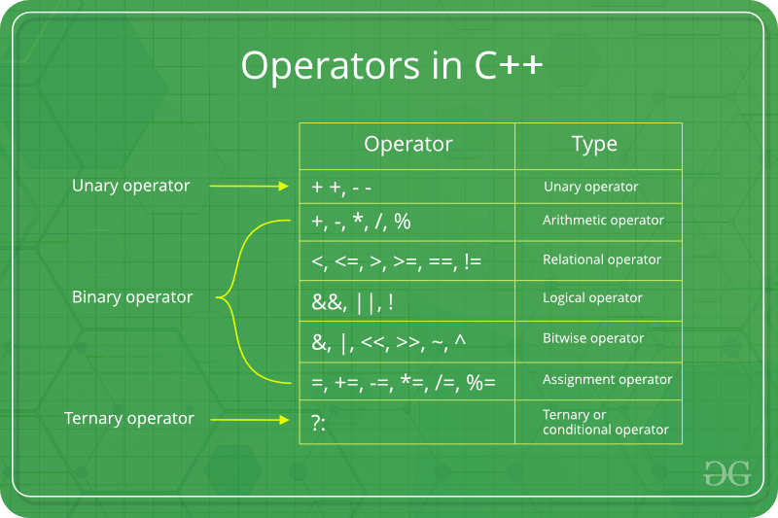

**Logical Operators**

These operators are used to combine two or more conditions or constraints or to complement the evaluation of the original condition in consideration. The result returns a Boolean value, i.e., **true** or **false**.

| **Name** | **Symbol** | **Description** | **Example** |
| --- | --- | --- | --- |
| Logical AND | && | Returns true only if all the operands are true or non-zero | int a = 3, b = 6;    a&&b;  // returns true |
| Logical OR | || | Returns true if either of the operands is true or non-zero | int a = 3, b = 6;  a||b;  // returns true |
| Logical NOT | ! | Returns true if the operand is false or zero | int a = 3;  !a;  // returns false |

C++

// CPP Program to demonstrate the Logical Operators

#include <iostream>

using namespace std;

int main()

{

int a = 6, b = 4;

// Logical AND operator

cout << "a && b is " << (a && b) << endl;

// Logical OR operator

cout << "a ! b is " << (a > b) << endl;

// Logical NOT operator

cout << "!b is " << (!b) << endl;

return 0;

}

**Output**

a && b is 1

a ! b is 1

!b is 0

Here, **0** denotes **false**and**1** denotes **true**.

**Short-Circuiting in Logical Operators:**

* In the case of **logical AND**, the second operand is not evaluated if the first operand is false. For example, program 1 below doesn’t print “GeeksQuiz” as the first operand of logical AND itself is false.

C++

#include <iostream>

using namespace std;

int main()

{

int a = 10, b = 4;

bool res = ((a == b) && cout << "GeeksQuiz");

return 0;

}

**Output**

* But the below program prints “GeeksQuiz” as the first operand of logical AND is true.

C++

#include <iostream>

using namespace std;

int main()

{

int a = 10, b = 4;

bool res = ((a != b) && cout << "GeeksQuiz");

return 0;

}

**Output**

GeeksQuiz

* In the case of **logical OR**, the second operand is not evaluated if the first operand is true. For example, program 1 below doesn’t print “GeeksQuiz” as the first operand of logical OR itself is true.

C++

#include <iostream>

using namespace std;

int main()

{

int a = 10, b = 4;

bool res = ((a != b) || cout << "GeeksQuiz");

return 0;

}

**Output**

* But the below program prints “GeeksQuiz” as the first operand of logical OR is false.

C++

#include <iostream>

using namespace std;

int main()

{

int a = 10, b = 4;

bool res = ((a == b) || cout << "GeeksQuiz");

return 0;

}

**Output**

GeeksQuiz

There is also a **three-way comparison operator** in C++ called **<=>**, which is sometimes called the **"spaceship operator."** This operator compares two values and returns:

* 0 if the values are equal
* 1 if the first value is greater than the second value
* -1 if the first value is less than the second value

This operator was introduced in **C++20** and can be used as an alternative to chaining together multiple comparisons using the <, ==, and > operators.

C++

int result = a <=> b;

if (result == 0) {

// a and b are equal

} else if (result == 1) {

// a is greater than b

} else if (result == -1) {

// a is less than b

}